
Koneru Lakshmaiah Education Foundation
(Deemed to be University estd. u/s. 3 of the UGC Act, 1956)
Off-Campus: Bachupally-Gandimaisamma Road, Bowrampet, Hyderabad, Telangana - 500 043. Phone No: 7815926816, www.klh.edu.in

STUDENT CASE STUDY EXECUTION REPORT
Department | FED
Subject | DSA-2
Academic Year | 1-111 Semester | 2025-26
Faculty Name | LAHARI
Student Name | S.VENNELA
Roll Number | 2520080018
Branch | AI&DS
Course Outcome | 6
Case Study Topic : JobMatch Candidate Profile Optimization using Dynamic Programming
Work Done Summary: we designed and implemented a JobMatch Candidate Profile Optimization System using the Dynamic Programming (0/1 Knapsack) algorithm. Each candidate profile contains multiple skills, experience levels, certifications, and project achievements, while each job posting specifies the required skills and eligibility criteria. The system evaluates every candidate profile by assigning scores based on skill relevance and experience. Dynamic Programming is then applied to compute the optimal combination of candidate attributes that maximizes the overall job-match score while satisfying the job requirements. This approach eliminates redundant calculations, improves recommendation accuracy, and efficiently identifies the most suitable candidates for recruiters. The optimized candidate ranking enables faster recruitment decisions and enhances the overall performance of the JobMatch platform by providing accurate and scalable profile recommendations.
Implementation Details:
- Represented each candidate profile with attributes such as Candidate ID, Skills, Experience, Certifications, and Match Score.
- Assigned weights based on required experience and values based on skill relevance to the job description.
- Stored candidate profile data in arrays and initialized a Dynamic Programming (DP) table to compute the maximum possible match score.
- Applied the 0/1 Knapsack Dynamic Programming algorithm to evaluate candidate profiles and determine the optimal combination of skills
- Calculated the highest job-match score for each candidate while avoiding redundant computations through memoization.
- Ranked all candidates in descending order of their final match scores.
- Selected the top-ranked candidate(s) as the most suitable recommendations for the recruiter.
- Compared the execution time of the Dynamic Programming approach with a brute-force method and observed significant improvement in efficiency for larger datasets.
- Verified the output by testing multiple candidate profiles and job requirements, ensuring accurate and optimal candidate recommendations.

Result: Screenshots / Output
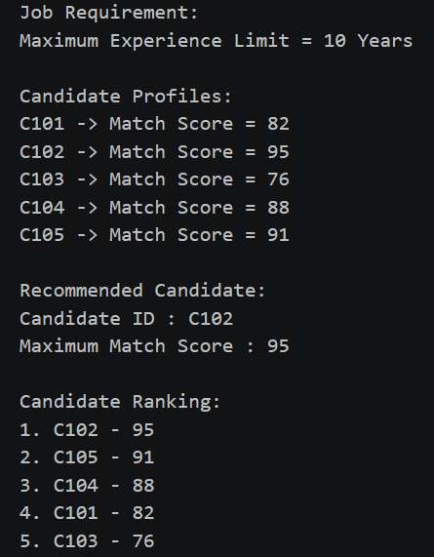
Time Complexity:-

Dynamic Programming (0/1 Knapsack): O(n × W)
The algorithm efficiently computes the maximum job-match score by avoiding redundant calculations, making candidate profile optimization faster and scalable.

GETHUB LINK : https://github.com/SVennela07/dsa-2-case-study

Student Signature Faculty Signature

